Building Blocks for Draft: Skills and Strategies
Beginner and Intermediate levels: NCA BDD and DD
9:00am-12:00pm Sunday March 23, 2024

In this workshop, we will present the basic skills you need to start draft work with your dog. We all utilize these skills in day-to-day activities as well as other dog sports. For this reason, you may participate in this workshop with or without a cart. When honed, these skills help you succeed in NCA draft tests. We will demonstrate how to train, practice and reinforce these skills, both in and out of a draft cart. This will be a hands-on workshop, during which each team will be able to actively practice the building block skills at their own current ability levels.

BDD/DD Building Blocks Skills
- Walking under control
- Back
- Stop
- Stay (from various distances and durations)
- Recall
- Slow
- Turns and Pivots
We will offer strategic tips for how to perform the maneuvers of a draft test, using these skills so that you can identify and avoid common pitfalls. You will receive a chart that lists all the components of the NCA BDD and DD tests and where each of the above skills are used.

For everyone who will be participating with a cart, we will schedule short individual appointments at the start of the day to check your harness fit and cart set up. We encourage everyone to observe this fit clinic as it offers fantastic opportunities to learn about how small adjustments made to the harness or cart can lead to big payoffs.

Tentative Schedule
9:00am Fit Clinic
10:00am-12:00pm Building Blocks for BDD and DD
What to Bring
A six-foot leash, lots of training treats, drool towels, a water bowl and a crate. A harness and draft apparatus if you plan to use it. Portions of the workshop will be conducted with your dogs in their carts, with the dogs out of their carts, and you will also do some segments on the floor while your dogs are crated.

Who Can Participate
This session is appropriate for all handlers. It is appropriate for any dogs that are comfortable working around other dogs and handlers. You do not need to have experience with draft to participate, but a good foundation of basic obedience is helpful.
**We will not be teaching how to introduce your dog to the draft cart in this workshop. We will have a handout available for those interested that explains the process.
Building Blocks for Draft: Skills and Strategies
Advanced level: NCA DDX
1:00-4:00pm Sunday March 23, 2024

Don’t be overwhelmed by DDX! This fun test is highly strategic, allowing each handler to play to their dog’s strengths as they complete the series of maneuvers. A successful DDX test requires a surprisingly small number of skills--but you will perform and combine them differently from one maneuver to the next. The better you are at these building blocks, the more likely you’ll be to pass the test.
In this workshop, we will break down each maneuver into its most basic components and show you what skills to train to pass the test. We will also offer strategic tips for how to perform the maneuvers, so that you can identify and avoid common pitfalls.

DDX Building Blocks Skills
- Stop
- Stay
- Pivot
- Back
- Go Out
- Recall
- Driving from behind

At the start of the session, we will check your harness fit and cart set up. We encourage everyone to observe this fit clinic, as it offers fantastic opportunities to learn about how small adjustments made to the harness or cart can lead to big payoffs.

Tentative Schedule
1:00pm Fit Clinic.
1:30-4:00pm Building Blocks for DDX

What to Bring
A leash (no flexi leashes please), lots of training treats, drool towels, a water bowl, your harness and draft apparatus, and a crate. Some parts of the workshop will be conducted with your dog in its cart, and during other parts you will work on the floor while your dog is crated.

Who Can Participate
This session is appropriate for all handlers. It is appropriate for any dogs that are comfortable pulling a cart, turning the cart, and working around other dogs and handlers. You do not need to have a DD or a BDD in order to participate.

Workshop leaders:

Kristin Julcher will be the leader of the morning workshop. Kristin has enjoyed drafting with three of her girls and has entered and participated in NCA draft tests at the BDD, DD and DDX levels. She and her girls have earned many NCA titles. Most recently Kristin handled her dog, Maisie, and Margaret’s dog, Poppy, to a TDD at the New England snow test in March, 2024.

Margaret Clayton will be the leader of the afternoon workshop. A professional horse trainer and riding instructor, Margaret believes in building solid foundational skills and a process-based approach to training. Margaret and her Landseer girl, Poppy, love draft and enjoy challenging themselves to become better with each test they enter. Poppy has 2 Draft Dog titles, one Team Draft Dog title (with Kristin!) and 7 Draft Dog Excellent titles. 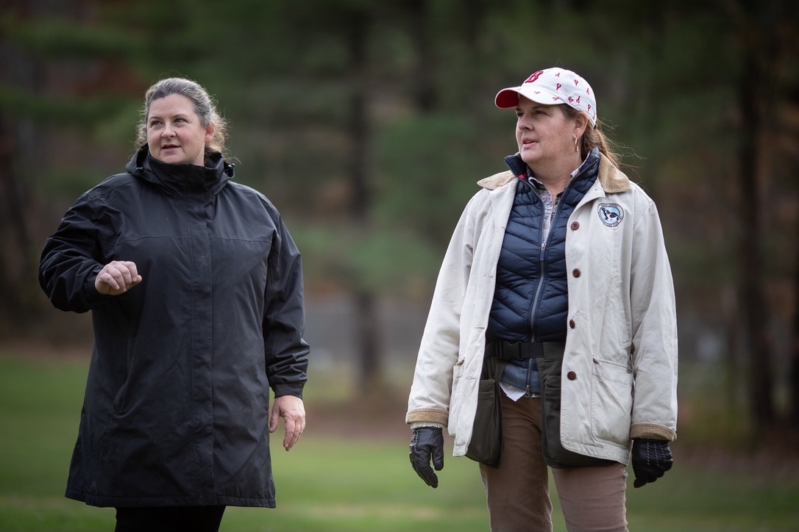
Photo credit: John Caldwell

